**@Author: Galvingwc**

**Introduction**

A Singaporean friend of mine, who has just graduated from university, and is looking to venture into entrepreneurship. Having graduated with a degree in sports science, he plans to open a supplement drinks store as his first local start-up business. However, he could not decide on a location to open his store. Hence, he approached me for help, knowing that I have experience in data science and is hopeful of me using data to locate the best possible location for his store.

**Data**

The data set that will be used contains the name of Singapore's neighbourhoods, and their geospatial coordinates. Subsequently, the Foursquare API will be utilised to obtain location and categorical data of nearby venues around the neighbourhoods. The data will be analysed, and the neighbourhoods will be grouped into clusters based on the mean frequency of occurrence of nearby venues by category. Hence, this helps to visualise the clusters characteristics. Noting that the target customers for a supplement drinks store would be fitness enthusiasts, the ideal location would be in clusters which has the highest mean frequency of fitness centres (complementary business) and lowest mean frequency of coffee shops/restaurants (competitive business).

**Methodology**

1. Import relevant libraries
2. Import data frame from Singapore_Neighbourhoods.csv using pandas.
3. Create a map of Singapore with pop up markers at all neighbourhoods using folium.
4. Create and run function to obtain nearby venues’ information using the Foursquare API.
5. Create new data frame of nearby venues using one-hot encoding.
6. Group data frame by neighbourhood, with features containing mean of venue occurrence.
7. Create function to sort and return the mean of venue occurrence in descending order.
8. Create new data frame of top 10 nearby venues by neighbourhood.
9. Find optimal value of k for k-means using the elbow method.
10. Initiate k-means clustering using KMeans.
11. Merge and clean data frame with neighbourhood, cluster label and top 10 nearby venues.
12. Create a map of Singapore with pop up markers of different colours representing different clusters using folium.
13. Examine data frame of the different clusters to determine unique characteristic.

**Results**

Graph of k against sum of squared distance:

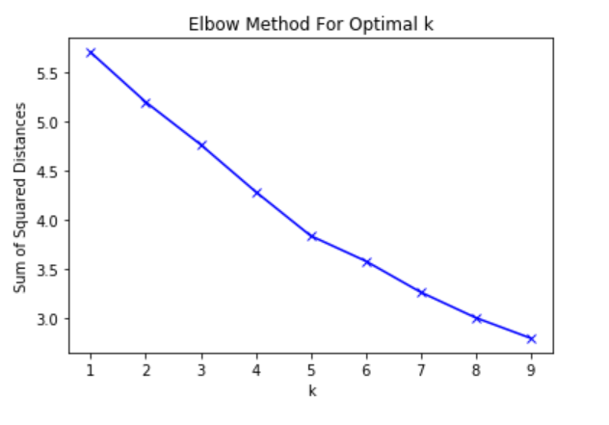

Folium map of 5 different clusters in Singapore:

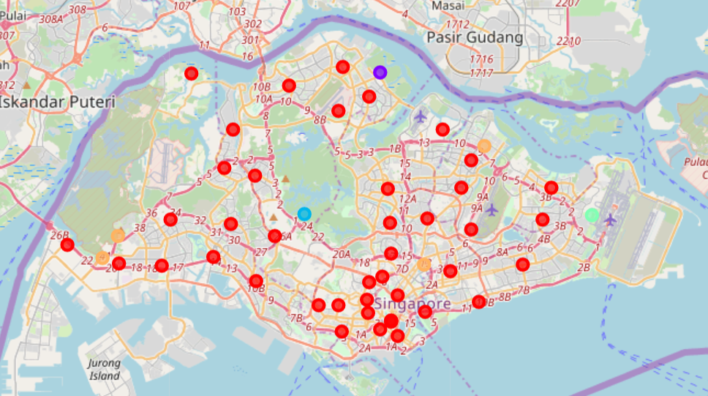

Cluster 1:

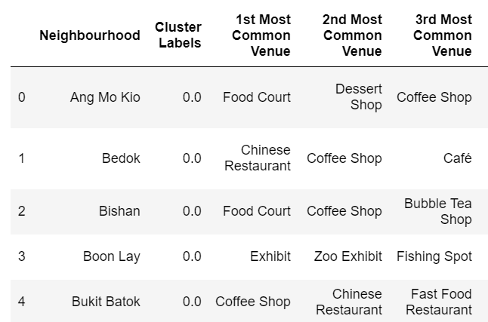

Cluster 2: 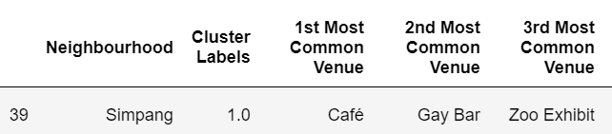

Cluster 3: 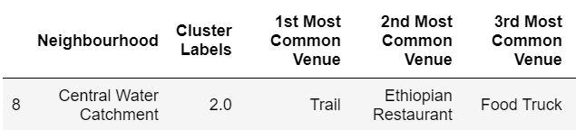

Cluster 4: 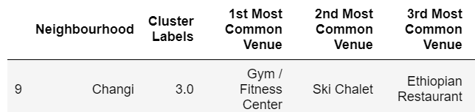

Cluster 5:

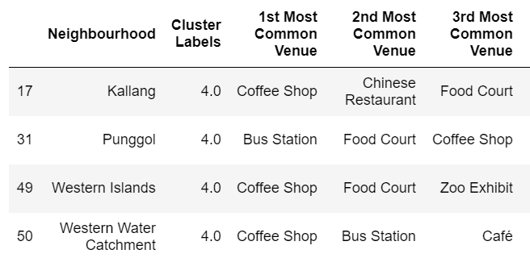

**Discussion**

To determine the optimal value of k for the k-means clustering algorithm, a range of values of k is used to iteratively run the algorithm. The sum of squared error for each value of k can then be calculated and a graph of the values of k can be plotted against sum of squared errors. Using the elbow method, the optimal value of k can be observed to be the sharp point joining 2 lines, which is k=5.

Using k=5 for the k-means clustering algorithm, a folium map displaying the 5 different clusters of neighbourhoods in Singapore can be created. From the map, it can be observed that majority of the neighbourhoods fall under the red cluster (cluster 1). The remaining clusters are the purple, blue, teal and orange cluster (cluster 2, 3, 4 and 5) which contains 1, 1, 1, 4 neighbourhoods respectively.

By extracting out the different cluster’s data frames, the unique characteristic of each cluster can be determined upon closer inspection. After inspecting top 3 nearby venues for each neighbourhood in the 5 clusters, they can be grouped into:

**Cluster 1**: Food court/Restaurant

**Cluster 2**: Café/Bar

**Cluster 3**: Park/Trail

**Cluster 4**: Fitness/Recreation

**Cluster 5**: Coffee shop/Bus station

Based on these groupings and keeping the business problem in mind, the best cluster to locate the supplement drinks store can finally be decided. Since cluster 1, 2 and 5 contains many venues with competing businesses, it is only wise to avoid them. The remaining cluster 3 and 4 are both suitable and complementary to the drinks business. However, it can be noted that cluster 3 contains parks and nature trails whereas cluster 4 contains gyms and fitness centres. With target customers who are fitness enthusiasts, the most ideal cluster to locate a supplement drinks store would be cluster 4. Furthermore, nature parks and trails more isolated compared to gyms and fitness centres which are more accessible. Hence, since cluster 4 contains only 1 neighbourhood, it can be decided that the best location to locate the supplement drinks store would be in Changi.

**Conclusion**

By utilising the available data sets online and location data from Foursquare API, data analysis can be done using machine learning algorithms. This reduces the risk of decision-making and increases the rate of success. Data analysis for decision-making can be applied to many other fields and are not limited to retail businesses. Hence, data analysis is an important and beneficial skill to have.

**Appendix**

Singapore_Neighbourhoods.csv:

|  |  |  |
| --- | --- | --- |
| **Neighbourhood** | **Latitude** | **Longitude** |
| Ang Mo Kio | 1.37173 | 103.8476 |
| Bedok | 1.32466 | 103.9324 |
| Bishan | 1.3504 | 103.8487 |
| Boon Lay | 1.3238 | 103.7061 |
| Bukit Batok | 1.35002 | 103.7493 |
| Bukit Merah | 1.28265 | 103.8187 |
| Bukit Panjang | 1.38006 | 103.7643 |
| Bukit Timah | 1.34242 | 103.7766 |
| Central Water Catchment | 1.35586 | 103.7953 |
| Changi | 1.35558 | 103.975 |
| Choa Chu Kang | 1.38511 | 103.745 |
| Clementi | 1.31435 | 103.7652 |
| Downtown Core | 1.28944 | 103.85 |
| Geylang | 1.32061 | 103.8869 |
| Hougang | 1.37258 | 103.8937 |
| Jurong East | 1.32949 | 103.7383 |
| Jurong West | 1.35223 | 103.7113 |
| Kallang | 1.3241 | 103.8705 |
| Lim Chu Kang | 1.44399 | 103.7247 |
| Mandai | 1.42066 | 103.8167 |
| Marina East | 1.29517 | 103.8712 |
| Marina South | 1.23776 | 103.8521 |
| Marine Parade | 1.30128 | 103.9049 |
| Museum | 1.28944 | 103.85 |
| Newton | 1.31368 | 103.8362 |
| Novena | 1.31696 | 103.8442 |
| Orchard | 1.30257 | 103.8347 |
| Outram | 1.284 | 103.8426 |
| Pasir Ris | 1.37244 | 103.9496 |
| Paya lebar | 1.3463 | 103.8996 |
| Pioneer | 1.32514 | 103.6794 |
| Punggol | 1.39849 | 103.9079 |
| Queenstown | 1.29883 | 103.804 |
| River Valley | 1.2939 | 103.8353 |
| Rochor | 1.30544 | 103.8539 |
| Seletar | 1.409 | 103.8816 |
| Sembawang | 1.4482 | 103.8195 |
| Sengkang | 1.38931 | 103.8995 |
| Serangoon | 1.35345 | 103.8724 |
| Simpang | 1.44435 | 103.8427 |
| Singapore River | 1.28854 | 103.8493 |
| Southern Islands | 1.23776 | 103.8521 |
| Straits View | 1.27978 | 103.8535 |
| Sungei Kadut | 1.40912 | 103.7509 |
| Tampines | 1.35248 | 103.9446 |
| Tanglin | 1.29908 | 103.8164 |
| Tengah | 1.3575 | 103.7315 |
| Toa Payoh | 1.33146 | 103.8495 |
| Tuas | 1.33645 | 103.6471 |
| Western Islands | 1.32863 | 103.6687 |
| Western Water Catchment | 1.34218 | 103.6785 |
| Woodlands | 1.43605 | 103.7861 |
| Yishun | 1.42972 | 103.8359 |